“Registration of Free Negroes,” Fairfax County, Virginia
Sarah Jasper’s Record
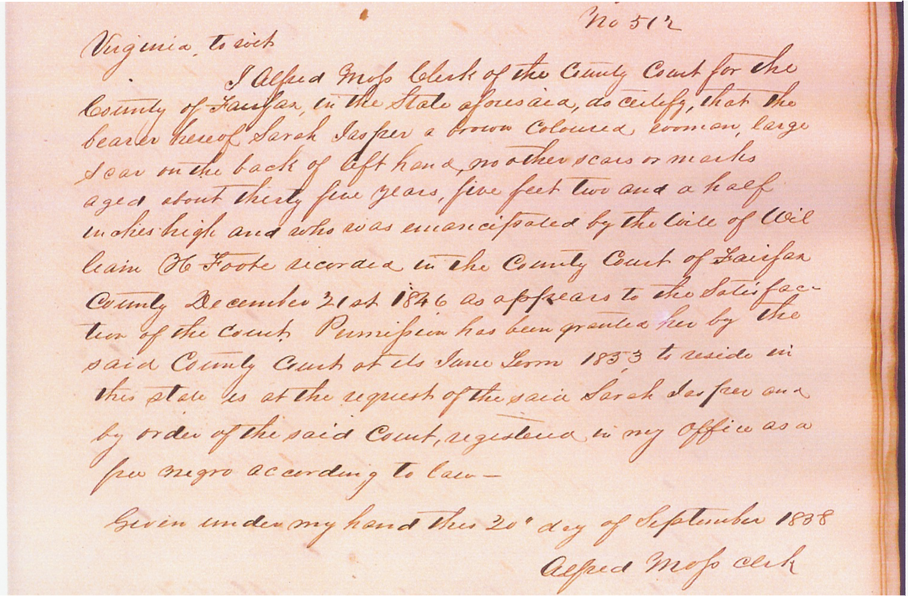

Susan and Eliza Jasper’s Record

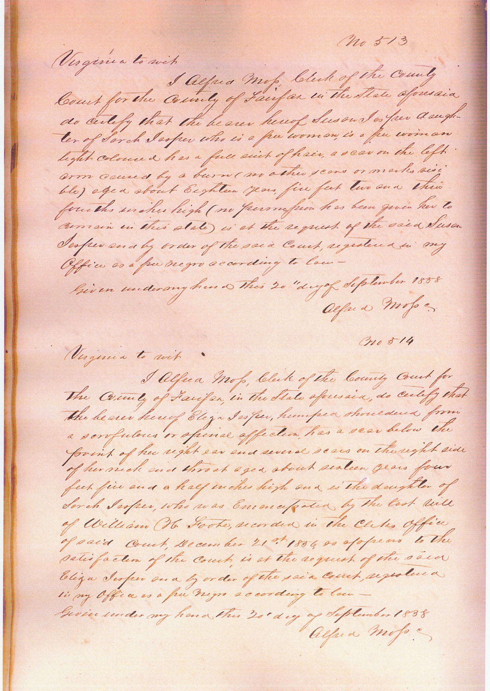
William Jasper’s Record



