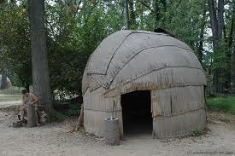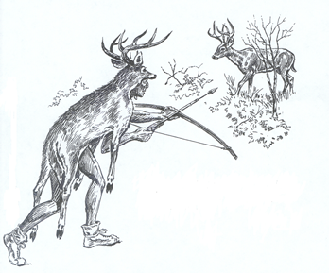
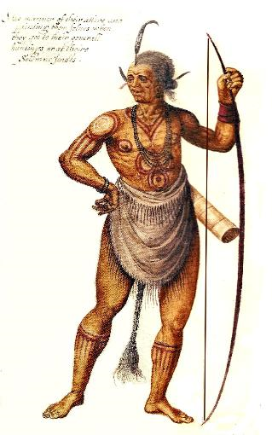
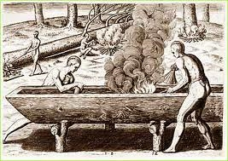

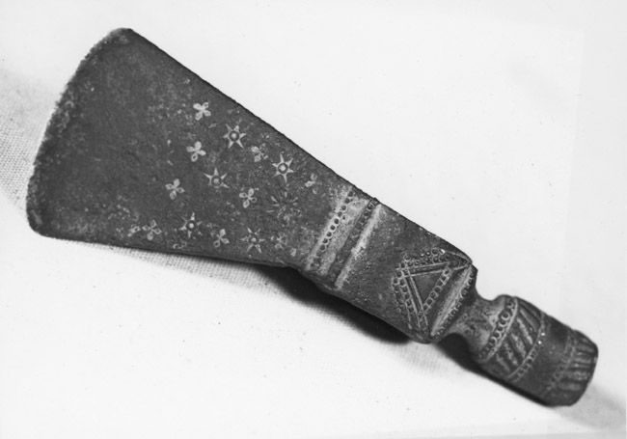

What do you see?

What natural resource(s) is it made of?

What is its use?

Could it be used all year long?

What do you see?

What natural resource(s) is it made of?

What is its use?

Could it be used all year long?

What do you see?

What natural resource(s) is it made of?

What is its use?

Could it be used all year long?

What do you see?

What natural resource(s) is it made of?

What is its use?

Could it be used all year long?

What do you see?

What natural resource(s) is it made of?

What is its use?

Could it be used all year long?

What do you see?

What natural resource(s) is it made of?

What is its use?

Could it be used all year long?

